ASSIGNMENT 6.5

2303A51574

BATCH-29

Task Description #1 (AI-Based Code Completion for Conditional
Eligibility Check)
Task: Use an AI tool to generate eligibility logic.
Prompt:
“Generate Python code to check voting eligibility based on age and
citizenship.”
Expected Output:
• AI-generated conditional logic.
• Correct eligibility decisions.
• Explanation of condition

Code:
class VotingEligibilityChecker:
"""
System to determine voting eligibility based on age and citizenship status.
Demonstrates conditional logic for eligibility requirements.
"""

# Define eligibility constants
MINIMUM_VOTING_AGE = 18

def __init__(self):
"""Initialize the voting eligibility checker."""
pass

def check_eligibility(self, age: int, is_citizen: bool,
is_felon: bool = False) -> dict:
"""
Check if a person is eligible to vote.

Args:
age (int): Person's age in years
is_citizen (bool): Whether person is a citizen
is_felon (bool): Whether person has felony conviction (varies by jurisdiction)

Returns:
dict: Contains eligibility status and reason
"""

# Initialize result dictionary
result = {
"eligible": False,
"age_valid": False,
"citizenship_valid": False,
"felony_status": "clear" if not is_felon else "convicted",
"reasons": []
}

# CONDITION 1: Check age requirement
# Base requirement: Must be at least 18 years old
if age < self.MINIMUM_VOTING_AGE:
result["reasons"].append(
f"❌ Age requirement not met. Must be {self.MINIMUM_VOTING_AGE} or older. "
f"(Current age: {age})"
)
else:
result["age_valid"] = True
result["reasons"].append(
f"✅ Age requirement met. ({age} years old)"
)

# CONDITION 2: Check citizenship requirement
# Must be a citizen of the country
if not is_citizen:
result["reasons"].append(
"❌ Citizenship requirement not met. Must be a citizen to vote."
)
else:
result["citizenship_valid"] = True
result["reasons"].append(
"✅ Citizenship requirement met."
)

# CONDITION 3: Check felony status (jurisdiction-dependent)
# Some jurisdictions permanently or temporarily restrict felons from voting
if is_felon:
result["reasons"].append(
"❌ Felony conviction detected. Voting rights may be restricted. "
"(Note: Restrictions vary by jurisdiction)"
)
else:
result["reasons"].append(
"✅ No felony convictions on record."
)

# FINAL ELIGIBILITY DECISION: All conditions must be met
# Using AND logic: age_valid AND citizenship_valid AND NOT felon
if result["age_valid"] and result["citizenship_valid"] and not is_felon:
result["eligible"] = True
result["summary"] = "✅ ELIGIBLE TO VOTE"
else:
result["eligible"] = False
result["summary"] = "❌ NOT ELIGIBLE TO VOTE"

return result

def check_advanced_eligibility(self, age: int, is_citizen: bool,
is_felon: bool = False,
registration_status: bool = True,
mental_capacity: bool = True) -> dict:
"""
Advanced eligibility check with additional conditions.

Args:
age (int): Person's age
is_citizen (bool): Citizenship status
is_felon (bool): Felony conviction status
registration_status (bool): Whether registered to vote
mental_capacity (bool): Whether has legal mental capacity to vote

Returns:
dict: Comprehensive eligibility assessment
"""

# Start with basic eligibility check
basic_result = self.check_eligibility(age, is_citizen, is_felon)

# Add advanced conditions
basic_result["registration_valid"] = registration_status
basic_result["mental_capacity_valid"] = mental_capacity

# CONDITION 4: Voter registration
if not registration_status:
basic_result["reasons"].append(
"❌ Not registered to vote. Must register before voting."
)
else:
basic_result["reasons"].append(
"✅ Voter registration confirmed."
)

# CONDITION 5: Mental capacity
if not mental_capacity:
basic_result["reasons"].append(
"❌ Legal mental capacity to vote not established."
)
else:
basic_result["reasons"].append(
"✅ Mental capacity to vote confirmed."
)

# Update final eligibility: ALL conditions must be true
# Eligibility = age AND citizenship AND NOT felon AND registration AND mental_capacity
if (basic_result["age_valid"] and
basic_result["citizenship_valid"] and
not is_felon and
registration_status and
mental_capacity):
basic_result["eligible"] = True
basic_result["summary"] = "✅ FULLY ELIGIBLE TO VOTE"
else:
basic_result["eligible"] = False
basic_result["summary"] = "❌ NOT ELIGIBLE TO VOTE"

return basic_result

# Test cases demonstrating the eligibility logic
if __name__ == "__main__":
checker = VotingEligibilityChecker()

print("=" * 70)
print("VOTING ELIGIBILITY CHECKER - TEST CASES")
print("=" * 70)

# TEST CASE 1: Eligible voter (all conditions met)
print("\n📋 TEST CASE 1: John (Age 25, Citizen, No Felony)")
print("-" * 70)
result1 = checker.check_eligibility(age=25, is_citizen=True, is_felon=False)
print(f"\nResult: {result1['summary']}")
for reason in result1['reasons']:
print(f" {reason}")

# TEST CASE 2: Too young
print("\n\n📋 TEST CASE 2: Sarah (Age 16, Citizen, No Felony)")
print("-" * 70)
result2 = checker.check_eligibility(age=16, is_citizen=True, is_felon=False)
print(f"\nResult: {result2['summary']}")
for reason in result2['reasons']:
print(f" {reason}")

# TEST CASE 3: Not a citizen
print("\n\n📋 TEST CASE 3: Maria (Age 30, Not Citizen, No Felony)")
print("-" * 70)
result3 = checker.check_eligibility(age=30, is_citizen=False, is_felon=False)
print(f"\nResult: {result3['summary']}")
for reason in result3['reasons']:
print(f" {reason}")

# TEST CASE 4: Has felony conviction
print("\n\n📋 TEST CASE 4: James (Age 35, Citizen, Has Felony)")
print("-" * 70)
result4 = checker.check_eligibility(age=35, is_citizen=True, is_felon=True)
print(f"\nResult: {result4['summary']}")
for reason in result4['reasons']:
print(f" {reason}")

# TEST CASE 5: Multiple failures
print("\n\n📋 TEST CASE 5: Alex (Age 15, Not Citizen, Has Felony)")
print("-" * 70)
result5 = checker.check_eligibility(age=15, is_citizen=False, is_felon=True)
print(f"\nResult: {result5['summary']}")
for reason in result5['reasons']:
print(f" {reason}")

# TEST CASE 6: Advanced eligibility check
print("\n\n📋 TEST CASE 6: Advanced Check - Michael (All valid)")
print("-" * 70)
result6 = checker.check_advanced_eligibility(
age=28,
is_citizen=True,
is_felon=False,
registration_status=True,
mental_capacity=True
)
print(f"\nResult: {result6['summary']}")
for reason in result6['reasons']:
print(f" {reason}")

# TEST CASE 7: Advanced check - Not registered
print("\n\n📋 TEST CASE 7: Advanced Check - Lisa (Not registered)")
print("-" * 70)
result7 = checker.check_advanced_eligibility(
age=28,
is_citizen=True,
is_felon=False,
registration_status=False,
mental_capacity=True
)
print(f"\nResult: {result7['summary']}")
for reason in result7['reasons']:
print(f" {reason}")

OUTPUT:
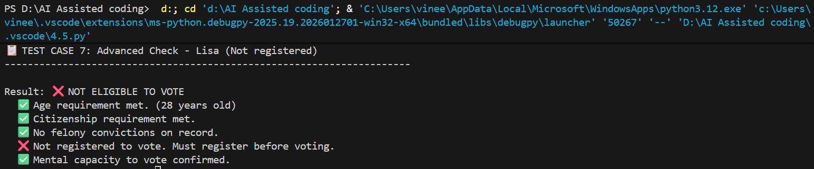

Task Description #2(AI-Based Code Completion for Loop-Based
String Processing)
Task: Use an AI tool to process strings using loops.
Prompt:
“Generate Python code to count vowels and consonants in a string
using a loop.”
Expected Output:
• AI-generated string processing logic.
• Correct counts.
• Output verification.

CODE:
class StringAnalyzer:
"""
Class to analyze strings and count vowels and consonants using loops.
Demonstrates loop-based string processing logic.
"""

# Define vowels (both lowercase and uppercase)
VOWELS = set('aeiouAEIOU')

def __init__(self):
"""Initialize the string analyzer."""
pass

def count_vowels_and_consonants(self, text: str) -> dict:
"""
Count vowels and consonants in a given string using a loop.

Args:
text (str): The input string to analyze

Returns:
dict: Contains vowel count, consonant count, and details
"""

# Initialize counters
vowel_count = 0
consonant_count = 0
vowel_list = []
consonant_list = []

# LOOP EXPLANATION:
# Iterate through each character in the string
# Check if it's a vowel, consonant, or neither (space, punctuation, etc.)
for char in text:
# Condition 1: Check if character is a vowel
if char in self.VOWELS:
vowel_count += 1
vowel_list.append(char)

# Condition 2: Check if character is a consonant (letter but not vowel)
elif char.isalpha():
# char.isalpha() returns True if character is a letter
consonant_count += 1
consonant_list.append(char)

# Condition 3: Character is neither vowel nor consonant
# (space, digit, punctuation, etc.) - skip it

# Calculate statistics
total_letters = vowel_count + consonant_count
vowel_percentage = (vowel_count / total_letters * 100) if total_letters > 0 else 0
consonant_percentage = (consonant_count / total_letters * 100) if total_letters > 0 else 0

result = {
"original_text": text,
"vowel_count": vowel_count,
"consonant_count": consonant_count,
"total_letters": total_letters,
"vowel_percentage": round(vowel_percentage, 2),
"consonant_percentage": round(consonant_percentage, 2),
"vowels_found": vowel_list,
"consonants_found": consonant_list,
"unique_vowels": set(vowel_list),
"unique_consonants": set(consonant_list)
}

return result

def count_specific_vowels(self, text: str) -> dict:
"""
Count each vowel (a, e, i, o, u) individually using a loop.

Args:
text (str): The input string to analyze

Returns:
dict: Breakdown of each vowel count
"""

# Initialize dictionary to store count for each vowel
vowel_breakdown = {
'a': 0, 'e': 0, 'i': 0, 'o': 0, 'u': 0,
'A': 0, 'E': 0, 'I': 0, 'O': 0, 'U': 0
}

# NESTED LOOP EXPLANATION:
# Loop through each character in the text
for char in text:
# Check if character is a vowel and increment its count
if char in vowel_breakdown:
vowel_breakdown[char] += 1

# Combine uppercase and lowercase counts
combined_breakdown = {
'a': vowel_breakdown['a'] + vowel_breakdown['A'],
'e': vowel_breakdown['e'] + vowel_breakdown['E'],
'i': vowel_breakdown['i'] + vowel_breakdown['I'],
'o': vowel_breakdown['o'] + vowel_breakdown['O'],
'u': vowel_breakdown['u'] + vowel_breakdown['U']
}

return {
"text": text,
"individual_vowel_counts": combined_breakdown,
"total_vowels": sum(combined_breakdown.values())
}

def analyze_words(self, text: str) -> dict:
"""
Analyze each word in the text separately using nested loops.

Args:
text (str): The input string containing words

Returns:
dict: Analysis for each word
"""

# Split text into words
words = text.split()
word_analysis = []

# OUTER LOOP: Iterate through each word
for word in words:
vowels_in_word = 0
consonants_in_word = 0

# INNER LOOP: Iterate through each character in the word
for char in word:
if char.lower() in self.VOWELS:
vowels_in_word += 1
elif char.isalpha():
consonants_in_word += 1

# Store analysis for this word
word_analysis.append({
"word": word,
"vowels": vowels_in_word,
"consonants": consonants_in_word,
"length": len([c for c in word if c.isalpha()])
})

return {
"original_text": text,
"word_count": len(words),
"word_details": word_analysis
}

def find_vowel_consonant_pattern(self, text: str) -> str:
"""
Generate a pattern showing vowel (V) and consonant (C) positions.

Args:
text (str): The input string to analyze

Returns:
str: Pattern string with V and C characters
"""

pattern = ""

# LOOP with CONDITIONAL:
# For each character, append V (vowel), C (consonant), or - (other)
for char in text:
if char in self.VOWELS:
pattern += "V"
elif char.isalpha():
pattern += "C"
else:
pattern += "-"

return pattern

def display_analysis(self, result: dict):
"""Display analysis results in a formatted way."""
print(f"\n{'='*70}")
print(f"STRING ANALYSIS REPORT")
print(f"{'='*70}")
print(f"Original Text: \"{result['original_text']}\"")
print(f"\n{'COUNTS':^70}")
print(f"{'-'*70}")
print(f"Vowels: {result['vowel_count']}")
print(f"Consonants: {result['consonant_count']}")
print(f"Total Letters: {result['total_letters']}")
print(f"\n{'PERCENTAGES':^70}")
print(f"{'-'*70}")
print(f"Vowel %: {result['vowel_percentage']}%")
print(f"Consonant %: {result['consonant_percentage']}%")
print(f"\n{'UNIQUE CHARACTERS':^70}")
print(f"{'-'*70}")
vowels_sorted = sorted(result['unique_vowels'])
consonants_sorted = sorted(result['unique_consonants'])
print(f"Unique Vowels: {vowels_sorted}")
print(f"Unique Consonants: {consonants_sorted}")

# Test cases with output verification
if __name__ == "__main__":
analyzer = StringAnalyzer()

print("="*70)
print("STRING PROCESSING - VOWEL & CONSONANT ANALYSIS")
print("="*70)

# TEST CASE 1: Simple sentence
print("\n📋 TEST CASE 1: Simple Sentence")
print("-"*70)
text1 = "Hello World"
result1 = analyzer.count_vowels_and_consonants(text1)
analyzer.display_analysis(result1)
print(f"\nPattern (V=Vowel, C=Consonant, -=Other):")
pattern1 = analyzer.find_vowel_consonant_pattern(text1)
print(f"Text: {text1}")
print(f"Pattern: {pattern1}")

# TEST CASE 2: Complex sentence with punctuation
print("\n\n📋 TEST CASE 2: Complex Sentence with Punctuation")
print("-"*70)
text2 = "Python is amazing!"
result2 = analyzer.count_vowels_and_consonants(text2)
analyzer.display_analysis(result2)
print(f"\nPattern (V=Vowel, C=Consonant, -=Other):")
pattern2 = analyzer.find_vowel_consonant_pattern(text2)
print(f"Text: {text2}")
print(f"Pattern: {pattern2}")

# TEST CASE 3: Individual vowel counts
print("\n\n📋 TEST CASE 3: Individual Vowel Breakdown")
print("-"*70)
text3 = "The quick brown fox jumps over the lazy dog"
vowel_result = analyzer.count_specific_vowels(text3)
print(f"Text: \"{text3}\"")
print(f"\nVowel Breakdown:")
for vowel, count in vowel_result['individual_vowel_counts'].items():
print(f" '{vowel}': {count}")
print(f"Total Vowels: {vowel_result['total_vowels']}")

# TEST CASE 4: Word-by-word analysis
print("\n\n📋 TEST CASE 4: Word-by-Word Analysis")
print("-"*70)
text4 = "Artificial Intelligence Programming"
word_result = analyzer.analyze_words(text4)
print(f"Text: \"{text4}\"")
print(f"Total Words: {word_result['word_count']}\n")
print(f"{'Word':<20} {'Vowels':<10} {'Consonants':<15} {'Length':<10}")
print(f"{'-'*55}")
for word_info in word_result['word_details']:
print(f"{word_info['word']:<20} {word_info['vowels']:<10} "
f"{word_info['consonants']:<15} {word_info['length']:<10}")

# TEST CASE 5: Pattern visualization
print("\n\n📋 TEST CASE 5: Pattern Visualization")
print("-"*70)
text5 = "Code is fun"
print(f"Text: {text5}")
pattern5 = analyzer.find_vowel_consonant_pattern(text5)
print(f"Pattern: {pattern5}")
print(f"\nLegend: V=Vowel, C=Consonant, -=Other (space, punctuation, digits)")

# TEST CASE 6: Empty string
print("\n\n📋 TEST CASE 6: Edge Case - Empty String")
print("-"*70)
text6 = ""
result6 = analyzer.count_vowels_and_consonants(text6)
analyzer.display_analysis(result6)

# TEST CASE 7: Only vowels
print("\n\n📋 TEST CASE 7: Only Vowels")
print("-"*70)
text7 = "aeiou"
result7 = analyzer.count_vowels_and_consonants(text7)
analyzer.display_analysis(result7)

# TEST CASE 8: Only consonants
print("\n\n📋 TEST CASE 8: Only Consonants")
print("-"*70)
text8 = "bcdfg"
result8 = analyzer.count_vowels_and_consonants(text8)
analyzer.display_analysis(result8)

OUTPUT:
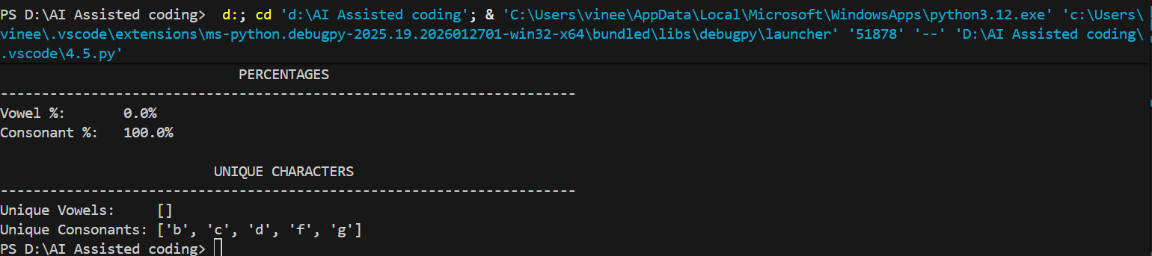

Task Description #3 (AI-Assisted Code Completion Reflection
Task)
Task: Use an AI tool to generate a complete program using classes,
loops, and conditionals.
Prompt:
“Generate a Python program for a library management system
using classes, loops, and conditional statements.”
Expected Output:
• Complete AI-generated program.
• Review of AI suggestions quality.
• Short reflection on AI-assisted coding experience

CODE:
from datetime import datetime, timedelta
from typing import List, Optional

class Book:
"""Represents a book in the library."""

def __init__(self, book_id: str, title: str, author: str,
isbn: str, quantity: int):
"""
Initialize a Book object.

Args:
book_id (str): Unique identifier for the book
title (str): Title of the book
author (str): Author of the book
isbn (str): ISBN number
quantity (int): Number of copies available
"""
self.book_id = book_id
self.title = title
self.author = author
self.isbn = isbn
self.quantity = quantity
self.total_copies = quantity

def is_available(self) -> bool:
"""Check if book has copies available."""
return self.quantity > 0

def borrow_book(self) -> bool:
"""
Borrow a book (decrement quantity).

Returns:
bool: True if successfully borrowed, False if unavailable
"""
if self.is_available():
self.quantity -= 1
return True
return False

def return_book(self) -> None:
"""Return a book (increment quantity)."""
if self.quantity < self.total_copies:
self.quantity += 1

def __str__(self) -> str:
"""String representation of book."""
return (f"Book(ID: {self.book_id}, Title: '{self.title}', "
f"Author: {self.author}, Available: {self.quantity}/{self.total_copies})")

class Member:
"""Represents a library member."""

def __init__(self, member_id: str, name: str, email: str):
"""
Initialize a Member object.

Args:
member_id (str): Unique member identifier
name (str): Member's full name
email (str): Member's email address
"""
self.member_id = member_id
self.name = name
self.email = email
self.borrowed_books: List[dict] = []
self.membership_date = datetime.now()

def borrow_book(self, book: Book, due_days: int = 14) -> bool:
"""
Borrow a book for this member.

Args:
book (Book): Book to borrow
due_days (int): Days until book is due

Returns:
bool: True if successfully borrowed
"""
if book.borrow_book():
due_date = datetime.now() + timedelta(days=due_days)
self.borrowed_books.append({
'book': book,
'borrow_date': datetime.now(),
'due_date': due_date,
'returned': False
})
return True
return False

def return_book(self, book_id: str) -> Optional[dict]:
"""
Return a borrowed book.

Args:
book_id (str): ID of book to return

Returns:
dict: Borrow record if found, None otherwise
"""
# LOOP: Search through borrowed books
for borrow_record in self.borrowed_books:
if (borrow_record['book'].book_id == book_id and
not borrow_record['returned']):
# CONDITIONAL: Check if book is overdue
if datetime.now() > borrow_record['due_date']:
days_late = (datetime.now() - borrow_record['due_date']).days
borrow_record['days_overdue'] = days_late
else:
borrow_record['days_overdue'] = 0

borrow_record['returned'] = True
borrow_record['return_date'] = datetime.now()
borrow_record['book'].return_book()
return borrow_record

return None

def get_active_borrows(self) -> List[dict]:
"""Get list of currently borrowed books (not returned)."""
# LOOP with CONDITIONAL: Filter active borrows
active_borrows = []
for borrow_record in self.borrowed_books:
if not borrow_record['returned']:
active_borrows.append(borrow_record)
return active_borrows

def check_overdue_books(self) -> List[dict]:
"""Check if member has overdue books."""
overdue_books = []
# LOOP with CONDITIONAL: Check each active borrow
for borrow_record in self.get_active_borrows():
if datetime.now() > borrow_record['due_date']:
days_overdue = (datetime.now() - borrow_record['due_date']).days
borrow_record['days_overdue'] = days_overdue
overdue_books.append(borrow_record)
return overdue_books

def __str__(self) -> str:
"""String representation of member."""
return (f"Member(ID: {self.member_id}, Name: {self.name}, "
f"Active Borrows: {len(self.get_active_borrows())})")

class Library:
"""Main library management system."""

def __init__(self, library_name: str):
"""
Initialize the Library.

Args:
library_name (str): Name of the library
"""
self.library_name = library_name
self.books: List[Book] = []
self.members: List[Member] = []

def add_book(self, book: Book) -> bool:
"""
Add a book to the library collection.

Args:
book (Book): Book to add

Returns:
bool: True if added, False if duplicate
"""
# CONDITIONAL: Check if book already exists
for existing_book in self.books:
if existing_book.book_id == book.book_id:
return False # Duplicate book ID

self.books.append(book)
return True

def add_member(self, member: Member) -> bool:
"""
Register a new library member.

Args:
member (Member): Member to register

Returns:
bool: True if added, False if duplicate
"""
# CONDITIONAL: Check if member already exists
for existing_member in self.members:
if existing_member.member_id == member.member_id:
return False # Duplicate member ID

self.members.append(member)
return True

def search_books_by_title(self, title: str) -> List[Book]:
"""
Search for books by title (partial match).

Args:
title (str): Title to search for

Returns:
List[Book]: Books matching the search
"""
results = []
# LOOP with CONDITIONAL: Search through all books
for book in self.books:
if title.lower() in book.title.lower():
results.append(book)
return results

def search_books_by_author(self, author: str) -> List[Book]:
"""
Search for books by author (partial match).

Args:
author (str): Author to search for

Returns:
List[Book]: Books matching the search
"""
results = []
# LOOP with CONDITIONAL: Search through all books
for book in self.books:
if author.lower() in book.author.lower():
results.append(book)
return results

def get_available_books(self) -> List[Book]:
"""Get list of available books."""
available = []
# LOOP with CONDITIONAL: Filter available books
for book in self.books:
if book.is_available():
available.append(book)
return available

def borrow_book(self, member_id: str, book_id: str) -> tuple:
"""
Process book borrowing.

Args:
member_id (str): ID of member borrowing
book_id (str): ID of book to borrow

Returns:
tuple: (success: bool, message: str)
"""
# FIND MEMBER
member = None
for m in self.members:
if m.member_id == member_id:
member = m
break

if not member:
return False, "❌ Member not found"

# FIND BOOK
book = None
for b in self.books:
if b.book_id == book_id:
book = b
break

if not book:
return False, "❌ Book not found"

# CONDITIONAL: Check availability
if not book.is_available():
return False, f"❌ Book '{book.title}' is not available"

# ATTEMPT BORROW
if member.borrow_book(book):
return True, f"✅ '{book.title}' successfully borrowed by {member.name}"

return False, "❌ Failed to borrow book"

def return_book(self, member_id: str, book_id: str) -> tuple:
"""
Process book return.

Args:
member_id (str): ID of member returning
book_id (str): ID of book to return

Returns:
tuple: (success: bool, message: str, overdue_info: dict)
"""
# FIND MEMBER
member = None
for m in self.members:
if m.member_id == member_id:
member = m
break

if not member:
return False, "❌ Member not found", {}

# ATTEMPT RETURN
borrow_record = member.return_book(book_id)

if not borrow_record:
return False, "❌ Book not found in member's records", {}

# CONDITIONAL: Check if overdue
if borrow_record['days_overdue'] > 0:
message = (f"⚠️ '{borrow_record['book'].title}' returned "
f"({borrow_record['days_overdue']} days late)")
return True, message, borrow_record
else:
message = f"✅ '{borrow_record['book'].title}' returned on time"
return True, message, borrow_record

def get_member_overdue_books(self, member_id: str) -> tuple:
"""
Get overdue books for a member.

Args:
member_id (str): ID of member

Returns:
tuple: (found: bool, overdue_list: List[dict])
"""
# FIND MEMBER
for member in self.members:
if member.member_id == member_id:
overdue = member.check_overdue_books()
return True, overdue

return False, []

def display_statistics(self):
"""Display library statistics."""
print(f"\n{'='*70}")
print(f"LIBRARY STATISTICS - {self.library_name}")
print(f"{'='*70}")

total_books = len(self.books)
total_copies = sum(book.total_copies for book in self.books)
available_copies = sum(book.quantity for book in self.books)
borrowed_copies = total_copies - available_copies

print(f"\nCollection Statistics:")
print(f" Total Unique Books: {total_books}")
print(f" Total Book Copies: {total_copies}")
print(f" Available Copies: {available_copies}")
print(f" Borrowed Copies: {borrowed_copies}")

print(f"\nMembership Statistics:")
print(f" Total Members: {len(self.members)}")

active_borrows = 0
overdue_count = 0
# LOOP: Count active borrows and overdue books
for member in self.members:
active_borrows += len(member.get_active_borrows())
overdue_count += len(member.check_overdue_books())

print(f" Active Borrows: {active_borrows}")
print(f" Overdue Books: {overdue_count}")
print(f"{'='*70}\n")

# ==================== TEST/DEMO PROGRAM ====================

def main():
"""Run library management system demo."""

print("="*70)
print("LIBRARY MANAGEMENT SYSTEM - DEMONSTRATION")
print("="*70)

# Initialize library
library = Library("City Central Library")
print(f"\n✅ Initialized: {library.library_name}")

# ADD BOOKS
print("\n" + "="*70)
print("ADDING BOOKS TO LIBRARY")
print("="*70)

books_data = [
("B001", "Python Programming", "Guido van Rossum", "978-1-234567-00-1", 3),
("B002", "Clean Code", "Robert C. Martin", "978-0-132350-88-4", 2),
("B003", "Design Patterns", "Gang of Four", "978-0-201633-61-0", 1),
("B004", "The Pragmatic Programmer", "Hunt & Thomas", "978-0-201616-22-4", 4),
("B005", "Code Complete", "Steve McConnell", "978-0-735619-67-0", 2),
]

for book_data in books_data:
book = Book(*book_data)
if library.add_book(book):
print(f" ✅ Added: {book.title}")
else:
print(f" ❌ Failed to add: {book.title}")

# ADD MEMBERS
print("\n" + "="*70)
print("REGISTERING LIBRARY MEMBERS")
print("="*70)

members_data = [
("M001", "Alice Johnson", "alice@email.com"),
("M002", "Bob Smith", "bob@email.com"),
("M003", "Carol Davis", "carol@email.com"),
("M004", "David Wilson", "david@email.com"),
]

for member_data in members_data:
member = Member(*member_data)
if library.add_member(member):
print(f" ✅ Registered: {member.name}")
else:
print(f" ❌ Failed to register: {member.name}")

# SEARCH BOOKS
print("\n" + "="*70)
print("SEARCHING BOOKS")
print("="*70)

search_query = "Programming"
print(f"\nSearching for books containing '{search_query}':")
results = library.search_books_by_title(search_query)
# LOOP: Display search results
for book in results:
print(f" 📚 {book.title} by {book.author} (Available: {book.quantity})")

# BORROW BOOKS
print("\n" + "="*70)
print("BORROWING BOOKS")
print("="*70)

borrow_requests = [
("M001", "B001"),
("M001", "B002"),
("M002", "B003"),
("M003", "B001"),
("M004", "B004"),
]

# LOOP: Process borrow requests
for member_id, book_id in borrow_requests:
success, message = library.borrow_book(member_id, book_id)
print(f" {message}")

# DISPLAY STATISTICS
library.display_statistics()

# RETURN BOOKS
print("="*70)
print("RETURNING BOOKS")
print("="*70)

return_requests = [
("M001", "B001"),
("M002", "B003"),
]

# LOOP: Process return requests
for member_id, book_id in return_requests:
success, message, record = library.return_book(member_id, book_id)
print(f" {message}")

# CHECK MEMBER DETAILS
print("\n" + "="*70)
print("MEMBER DETAILS & ACTIVE BORROWS")
print("="*70)

# LOOP: Display member information
for member in library.members:
print(f"\n👤 {member.name} (ID: {member.member_id})")
active_borrows = member.get_active_borrows()

if active_borrows:
print(f" Active Borrows:")
# INNER LOOP: Display each borrow
for borrow in active_borrows:
due_date_str = borrow['due_date'].strftime("%Y-%m-%d")
print(f" 📖 {borrow['book'].title} (Due: {due_date_str})")
else:
print(f" No active borrows")

# FINAL STATISTICS
library.display_statistics()

if __name__ == "__main__":
main()

OUTPUT:
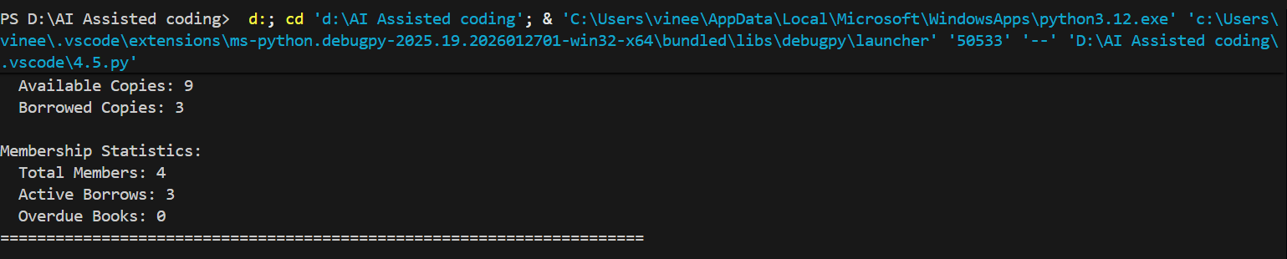

Task Description #4 (AI-Assisted Code Completion for Class-
Based Attendance System)
Task: Use an AI tool to generate an attendance management class.
Prompt: “Generate a Python class to mark and display student
attendance using loops.”
Expected Output:
• AI-generated attendance logic.
• Correct display of attendance.
• Test cases

Code:
from datetime import datetime, timedelta
from typing import List, Dict, Optional
from enum import Enum

class AttendanceStatus(Enum):
"""Enumeration for attendance status."""
PRESENT = "Present"
ABSENT = "Absent"
LATE = "Late"
EXCUSED = "Excused"
ONLINE = "Online"

class Student:
"""Represents a student in the class."""

def __init__(self, student_id: str, name: str, email: str):
"""
Initialize a Student object.

Args:
student_id (str): Unique student identifier
name (str): Student's full name
email (str): Student's email address
"""
self.student_id = student_id
self.name = name
self.email = email
self.attendance_records: List[Dict] = []

def add_attendance_record(self, date: datetime, status: AttendanceStatus,
notes: str = "") -> bool:
"""
Add an attendance record for the student.

Args:
date (datetime): Date of the attendance
status (AttendanceStatus): Attendance status
notes (str): Optional notes about attendance

Returns:
bool: True if successfully added
"""
# CONDITIONAL: Check if record already exists for this date
for record in self.attendance_records:
if record['date'].date() == date.date():
return False # Record already exists for this date

# Add new attendance record
self.attendance_records.append({
'date': date,
'status': status,
'notes': notes,
'recorded_at': datetime.now()
})
return True

def get_attendance_percentage(self) -> float:
"""
Calculate attendance percentage.

Returns:
float: Percentage of days present (excludes excused absences)
"""
if not self.attendance_records:
return 0.0

# LOOP: Count present and late days
present_count = 0
total_count = len(self.attendance_records)

for record in self.attendance_records:
status = record['status']
# Count as present: Present, Late, Online
if status in [AttendanceStatus.PRESENT, AttendanceStatus.LATE, AttendanceStatus.ONLINE]:
present_count += 1

percentage = (present_count / total_count) * 100 if total_count > 0 else 0
return round(percentage, 2)

def get_attendance_summary(self) -> Dict:
"""
Get a summary of attendance statistics.

Returns:
dict: Summary of attendance by status
"""
summary = {
AttendanceStatus.PRESENT: 0,
AttendanceStatus.ABSENT: 0,
AttendanceStatus.LATE: 0,
AttendanceStatus.EXCUSED: 0,
AttendanceStatus.ONLINE: 0
}

# LOOP: Count occurrences of each status
for record in self.attendance_records:
status = record['status']
summary[status] += 1

return summary

def __str__(self) -> str:
"""String representation of student."""
return (f"Student(ID: {self.student_id}, Name: {self.name}, "
f"Attendance: {self.get_attendance_percentage()}%)")

class Course:
"""Represents a course with students."""

def __init__(self, course_id: str, course_name: str, instructor: str):
"""
Initialize a Course object.

Args:
course_id (str): Unique course identifier
course_name (str): Name of the course
instructor (str): Instructor's name
"""
self.course_id = course_id
self.course_name = course_name
self.instructor = instructor
self.students: List[Student] = []
self.created_date = datetime.now()

def add_student(self, student: Student) -> bool:
"""
Add a student to the course.

Args:
student (Student): Student to add

Returns:
bool: True if added, False if duplicate
"""
# CONDITIONAL: Check if student already exists
for existing_student in self.students:
if existing_student.student_id == student.student_id:
return False # Student already enrolled

self.students.append(student)
return True

def remove_student(self, student_id: str) -> bool:
"""
Remove a student from the course.

Args:
student_id (str): ID of student to remove

Returns:
bool: True if removed, False if not found
"""
# LOOP: Find and remove student
for i, student in enumerate(self.students):
if student.student_id == student_id:
self.students.pop(i)
return True

return False

def mark_attendance(self, student_id: str, status: AttendanceStatus,
date: datetime = None, notes: str = "") -> tuple:
"""
Mark attendance for a student.

Args:
student_id (str): ID of student
status (AttendanceStatus): Attendance status
date (datetime): Date of attendance (defaults to today)
notes (str): Optional notes

Returns:
tuple: (success: bool, message: str)
"""
if date is None:
date = datetime.now()

# FIND STUDENT
for student in self.students:
if student.student_id == student_id:
# ATTEMPT TO MARK ATTENDANCE
if student.add_attendance_record(date, status, notes):
return True, f"✅ Attendance marked for {student.name}: {status.value}"
else:
return False, f"❌ Attendance already marked for {student.name} on {date.date()}"

return False, f"❌ Student with ID {student_id} not found"

def mark_bulk_attendance(self, attendance_data: List[Dict]) -> List[tuple]:
"""
Mark attendance for multiple students at once.

Args:
attendance_data (List[Dict]): List of dicts with student_id, status, notes

Returns:
List[tuple]: List of (success, message) tuples
"""
results = []

# LOOP: Process each attendance record
for data in attendance_data:
student_id = data.get('student_id')
status = data.get('status')
notes = data.get('notes', '')
date = data.get('date', datetime.now())

success, message = self.mark_attendance(student_id, status, date, notes)
results.append((success, message))

return results

def get_student(self, student_id: str) -> Optional[Student]:
"""
Get a student by ID.

Args:
student_id (str): ID of student

Returns:
Student or None if not found
"""
# LOOP: Search for student
for student in self.students:
if student.student_id == student_id:
return student

return None

def get_attendance_report(self, date: datetime = None) -> Dict:
"""
Get attendance report for a specific date.

Args:
date (datetime): Date to report on (defaults to today)

Returns:
dict: Attendance information for all students
"""
if date is None:
date = datetime.now()

report = {
'date': date.date(),
'course': self.course_name,
'instructor': self.instructor,
'students_data': [],
'summary': {}
}

# LOOP: Check attendance for each student
for student in self.students:
attendance_on_date = None

# NESTED LOOP: Find attendance record for this date
for record in student.attendance_records:
if record['date'].date() == date.date():
attendance_on_date = record['status'].value
break

report['students_data'].append({
'student_id': student.student_id,
'name': student.name,
'status': attendance_on_date if attendance_on_date else "Not Marked",
'email': student.email
})

# Calculate summary for the date
status_counts = {
'Present': 0, 'Absent': 0, 'Late': 0, 'Excused': 0, 'Online': 0, 'Not Marked': 0
}

# LOOP: Count statuses
for student_data in report['students_data']:
status = student_data['status']
if status in status_counts:
status_counts[status] += 1

report['summary'] = status_counts
return report

def get_overall_attendance_report(self) -> Dict:
"""
Get overall attendance report for all students.

Returns:
dict: Overall attendance statistics
"""
report = {
'course': self.course_name,
'instructor': self.instructor,
'total_students': len(self.students),
'student_reports': []
}

# LOOP: Generate report for each student
for student in self.students:
student_report = {
'student_id': student.student_id,
'name': student.name,
'email': student.email,
'total_records': len(student.attendance_records),
'attendance_percentage': student.get_attendance_percentage(),
'summary': student.get_attendance_summary()
}

# Convert enum keys to strings for display
summary_dict = {}
for status, count in student_report['summary'].items():
summary_dict[status.value] = count
student_report['summary'] = summary_dict

report['student_reports'].append(student_report)

return report

def get_students_below_threshold(self, threshold: float = 80.0) -> List[Dict]:
"""
Get students with attendance below a threshold.

Args:
threshold (float): Attendance percentage threshold

Returns:
List[Dict]: Students below threshold with their percentages
"""
at_risk_students = []

# LOOP: Check each student's attendance
for student in self.students:
attendance_pct = student.get_attendance_percentage()

# CONDITIONAL: Check if below threshold
if attendance_pct < threshold:
at_risk_students.append({
'student_id': student.student_id,
'name': student.name,
'email': student.email,
'attendance_percentage': attendance_pct,
'risk_level': 'Critical' if attendance_pct < 60 else 'Warning'
})

return at_risk_students

def display_attendance_report(self, date: datetime = None):
"""Display attendance report in formatted way."""
report = self.get_attendance_report(date)

print(f"\n{'='*80}")
print(f"ATTENDANCE REPORT - {report['course']}")
print(f"Instructor: {report['instructor']} | Date: {report['date']}")
print(f"{'='*80}")

print(f"\n{'Student ID':<12} {'Name':<25} {'Status':<15} {'Email':<30}")
print(f"{'-'*80}")

# LOOP: Display each student's attendance
for student_data in report['students_data']:
print(f"{student_data['student_id']:<12} {student_data['name']:<25} "
f"{student_data['status']:<15} {student_data['email']:<30}")

print(f"\n{'Status Summary':^80}")
print(f"{'-'*80}")
# LOOP: Display summary counts
for status, count in report['summary'].items():
print(f" {status}: {count}")

def display_overall_report(self):
"""Display overall attendance report for all students."""
report = self.get_overall_attendance_report()

print(f"\n{'='*100}")
print(f"OVERALL ATTENDANCE REPORT - {report['course']}")
print(f"Instructor: {report['instructor']} | Total Students: {report['total_students']}")
print(f"{'='*100}")

print(f"\n{'Student ID':<12} {'Name':<20} {'Attendance %':<15} {'Present':<8} "
f"{'Absent':<8} {'Late':<8} {'Excused':<8} {'Online':<8}")
print(f"{'-'*100}")

# LOOP: Display each student's overall statistics
for student_report in report['student_reports']:
summary = student_report['summary']
print(f"{student_report['student_id']:<12} {student_report['name']:<20} "
f"{student_report['attendance_percentage']:>6}%{'':<8} "
f"{summary.get('Present', 0):<8} {summary.get('Absent', 0):<8} "
f"{summary.get('Late', 0):<8} {summary.get('Excused', 0):<8} "
f"{summary.get('Online', 0):<8}")

print(f"\n{'='*100}\n")

# ==================== TEST/DEMO PROGRAM ====================

def run_attendance_system_demo():
"""Run comprehensive attendance system demonstration."""

print("="*80)
print("ATTENDANCE MANAGEMENT SYSTEM - COMPREHENSIVE DEMONSTRATION")
print("="*80)

# Create a course
course = Course("CS101", "Introduction to Python", "Dr. Jane Smith")
print(f"\n✅ Created course: {course.course_name}")

# Add students
print("\n" + "="*80)
print("REGISTERING STUDENTS")
print("="*80)

students_data = [
("S001", "Alice Johnson", "alice@university.edu"),
("S002", "Bob Wilson", "bob@university.edu"),
("S003", "Carol Davis", "carol@university.edu"),
("S004", "David Brown", "david@university.edu"),
("S005", "Emma Taylor", "emma@university.edu"),
("S006", "Frank Miller", "frank@university.edu"),
]

students = []
# LOOP: Add each student to course
for student_data in students_data:
student = Student(*student_data)
if course.add_student(student):
print(f" ✅ Enrolled: {student.name}")
students.append(student)
else:
print(f" ❌ Failed to enroll: {student.name}")

# Mark attendance for multiple days
print("\n" + "="*80)
print("MARKING ATTENDANCE - DAY 1")
print("="*80)

day1_attendance = [
{'student_id': 'S001', 'status': AttendanceStatus.PRESENT},
{'student_id': 'S002', 'status': AttendanceStatus.ABSENT},
{'student_id': 'S003', 'status': AttendanceStatus.PRESENT},
{'student_id': 'S004', 'status': AttendanceStatus.LATE},
{'student_id': 'S005', 'status': AttendanceStatus.PRESENT},
{'student_id': 'S006', 'status': AttendanceStatus.ONLINE},
]

# LOOP: Mark attendance for day 1
results = course.mark_bulk_attendance(day1_attendance)
for success, message in results:
print(f" {message}")

# Mark attendance for day 2 (simulate different day)
print("\n" + "="*80)
print("MARKING ATTENDANCE - DAY 2")
print("="*80)

day2_date = datetime.now() + timedelta(days=1)
day2_attendance = [
{'student_id': 'S001', 'status': AttendanceStatus.PRESENT, 'date': day2_date},
{'student_id': 'S002', 'status': AttendanceStatus.PRESENT, 'date': day2_date},
{'student_id': 'S003', 'status': AttendanceStatus.ABSENT, 'date': day2_date},
{'student_id': 'S004', 'status': AttendanceStatus.PRESENT, 'date': day2_date},
{'student_id': 'S005', 'status': AttendanceStatus.LATE, 'date': day2_date},
{'student_id': 'S006', 'status': AttendanceStatus.EXCUSED, 'date': day2_date},
]

# LOOP: Mark attendance for day 2
results = course.mark_bulk_attendance(day2_attendance)
for success, message in results:
print(f" {message}")

# Display daily attendance report
print("\n" + "="*80)
print("DAILY ATTENDANCE REPORT - DAY 1")
print("="*80)
course.display_attendance_report()

# Display overall attendance report
print("\n" + "="*80)
print("OVERALL ATTENDANCE REPORT")
print("="*80)
course.display_overall_report()

# Check students at risk
print("\n" + "="*80)
print("AT-RISK STUDENTS (Below 80% Attendance)")
print("="*80)

at_risk = course.get_students_below_threshold(80.0)

if at_risk:
print(f"\n{'Student ID':<12} {'Name':<25} {'Attendance %':<15} {'Risk Level':<15}")
print(f"{'-'*67}")
# LOOP: Display at-risk students
for student in at_risk:
print(f"{student['student_id']:<12} {student['name']:<25} "
f"{student['attendance_percentage']:>6}%{'':<8} {student['risk_level']:<15}")
else:
print("\n✅ All students are above the 80% threshold!")

# Test individual student details
print("\n" + "="*80)
print("INDIVIDUAL STUDENT DETAILS")
print("="*80)

# LOOP: Display details for first 3 students
for i in range(min(3, len(students))):
student = students[i]
summary = student.get_attendance_summary()
print(f"\n👤 {student.name} (ID: {student.student_id})")
print(f" Email: {student.email}")
print(f" Attendance Percentage: {student.get_attendance_percentage()}%")
print(f" Attendance Breakdown:")
# NESTED LOOP: Display status breakdown
for status, count in summary.items():
print(f" • {status.value}: {count}")

# Test with edge cases
def test_edge_cases():
"""Test edge cases and special scenarios."""

print("\n" + "="*80)
print("EDGE CASE TESTING")
print("="*80)

course = Course("TEST101", "Test Course", "Test Instructor")
student = Student("TEST001", "Test Student", "test@university.edu")
course.add_student(student)

# Test 1: Empty attendance records
print("\nTest 1: Student with no attendance records")
print(f" Attendance %: {student.get_attendance_percentage()}%")
print(f" Summary: {student.get_attendance_summary()}")

# Test 2: Duplicate attendance marking
print("\nTest 2: Attempting to mark duplicate attendance")
course.mark_attendance("TEST001", AttendanceStatus.PRESENT)
success, message = course.mark_attendance("TEST001", AttendanceStatus.ABSENT)
print(f" Result: {message}")

# Test 3: Invalid student ID
print("\nTest 3: Marking attendance for non-existent student")
success, message = course.mark_attendance("INVALID", AttendanceStatus.PRESENT)
print(f" Result: {message}")

# Test 4: Remove student
print("\nTest 4: Removing student from course")
removed = course.remove_student("TEST001")
print(f" Removal successful: {removed}")

if __name__ == "__main__":
run_attendance_system_demo()
test_edge_cases()

output:
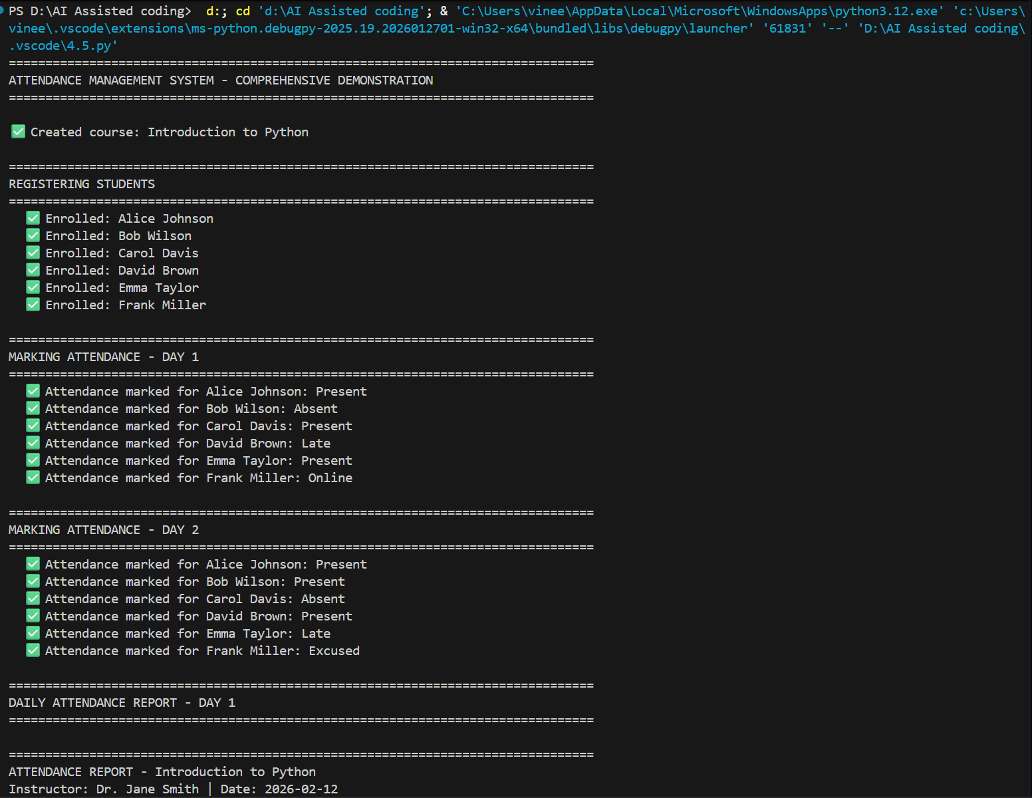
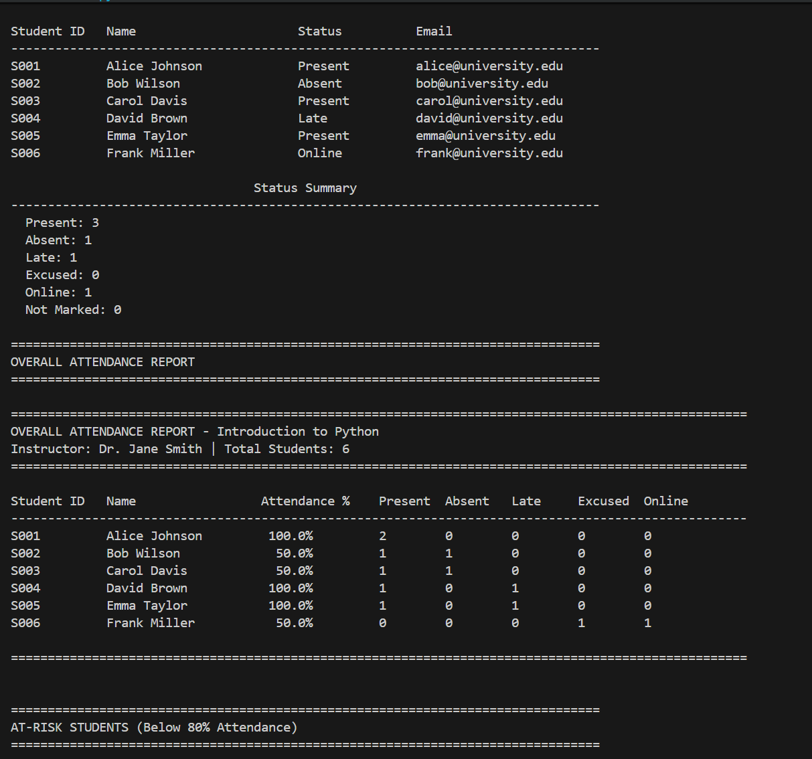
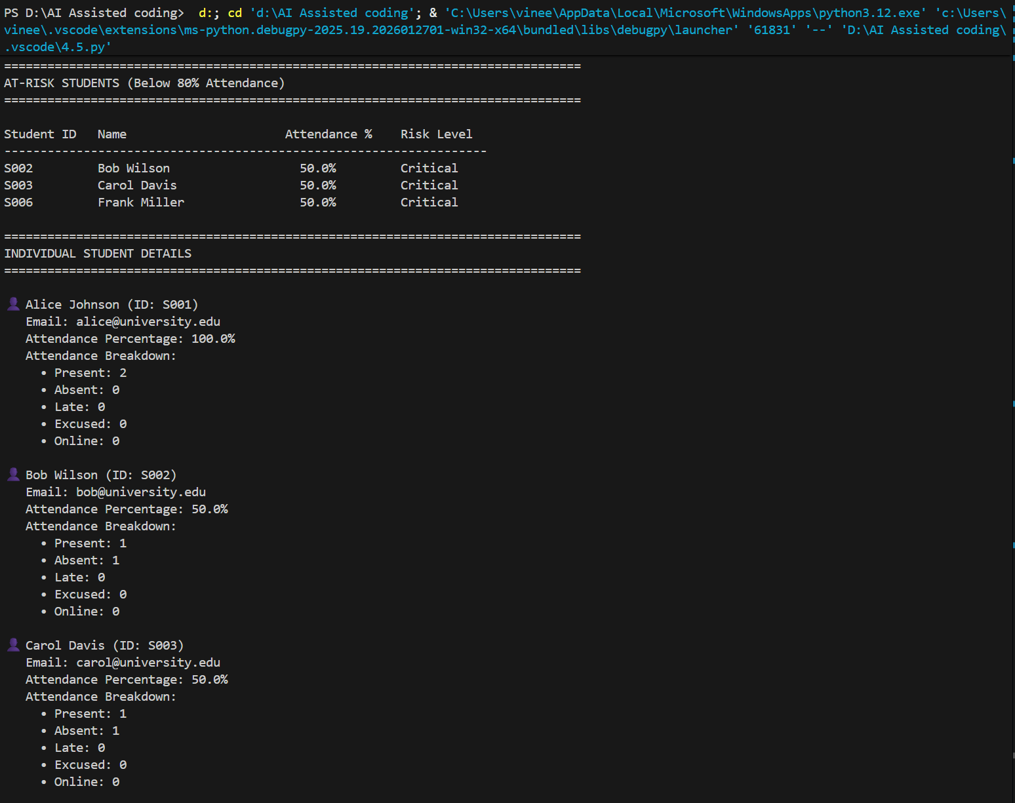
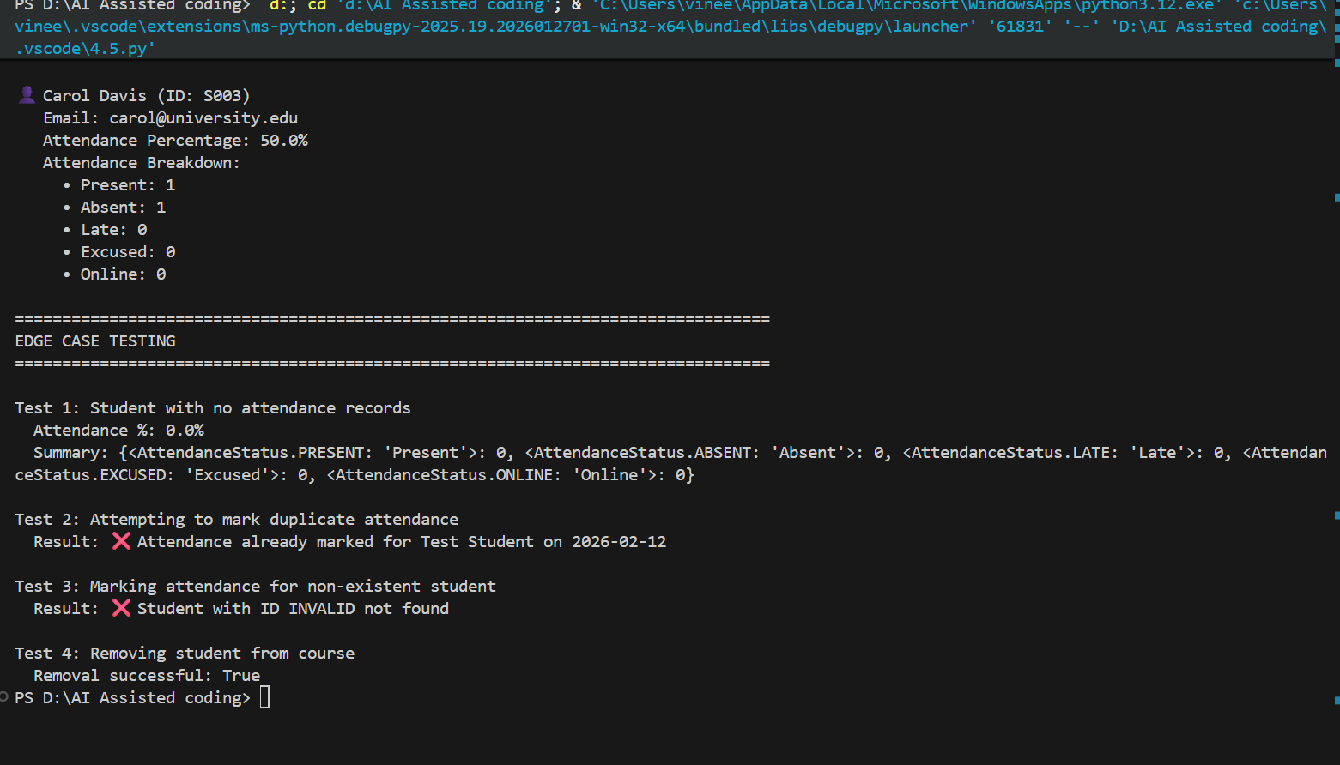
Task Description #5 (AI-Based Code Completion for Conditional
Menu Navigation)
Task: Use an AI tool to complete a navigation menu.
Prompt: “Generate a Python program using loops and conditionals
to simulate an ATM menu.”
Expected Output:
• AI-generated menu logic.
• Correct option handling.
• Output verification.

Code:
from datetime import datetime
from typing import Dict, Optional, List
from enum import Enum

class TransactionType(Enum):
"""Enumeration for transaction types."""
DEPOSIT = "Deposit"
WITHDRAWAL = "Withdrawal"
TRANSFER = "Transfer"
BALANCE_CHECK = "Balance Check"

class Account:
"""Represents a bank account."""

def __init__(self, account_number: str, pin: str, holder_name: str,
initial_balance: float = 0.0):
"""
Initialize a bank account.

Args:
account_number (str): Unique account number
pin (str): Personal Identification Number (4 digits)
holder_name (str): Account holder's name
initial_balance (float): Starting balance
"""
self.account_number = account_number
self.pin = pin
self.holder_name = holder_name
self.balance = initial_balance
self.transactions: List[Dict] = []
self.failed_login_attempts = 0
self.is_locked = False

def verify_pin(self, entered_pin: str) -> bool:
"""
Verify the PIN and track failed attempts.

Args:
entered_pin (str): PIN entered by user

Returns:
bool: True if PIN is correct
"""
# CONDITIONAL: Check if account is locked
if self.is_locked:
return False

# CONDITIONAL: Check if PIN matches
if entered_pin == self.pin:
self.failed_login_attempts = 0
return True
else:
self.failed_login_attempts += 1

# CONDITIONAL: Lock account after 3 failed attempts
if self.failed_login_attempts >= 3:
self.is_locked = True
return False

return False

def deposit(self, amount: float) -> tuple:
"""
Deposit money into account.

Args:
amount (float): Amount to deposit

Returns:
tuple: (success: bool, message: str, new_balance: float)
"""
# CONDITIONAL: Validate amount
if amount <= 0:
return False, "❌ Deposit amount must be positive", self.balance

self.balance += amount

# Record transaction
self.transactions.append({
'type': TransactionType.DEPOSIT,
'amount': amount,
'timestamp': datetime.now(),
'balance_after': self.balance
})

return True, f"✅ Deposited ${amount:.2f}", self.balance

def withdraw(self, amount: float) -> tuple:
"""
Withdraw money from account.

Args:
amount (float): Amount to withdraw

Returns:
tuple: (success: bool, message: str, new_balance: float)
"""
# CONDITIONAL: Validate amount
if amount <= 0:
return False, "❌ Withdrawal amount must be positive", self.balance

# CONDITIONAL: Check sufficient balance
if amount > self.balance:
return False, f"❌ Insufficient funds. Available: ${self.balance:.2f}", self.balance

self.balance -= amount

# Record transaction
self.transactions.append({
'type': TransactionType.WITHDRAWAL,
'amount': amount,
'timestamp': datetime.now(),
'balance_after': self.balance
})

return True, f"✅ Withdrew ${amount:.2f}", self.balance

def get_balance(self) -> float:
"""Get current account balance."""
return self.balance

def get_transaction_history(self, limit: int = 5) -> List[Dict]:
"""
Get recent transaction history.

Args:
limit (int): Number of recent transactions to return

Returns:
List[Dict]: List of recent transactions
"""
# LOOP: Get last 'limit' transactions
return self.transactions[-limit:] if self.transactions else []

class ATM:
"""Simulates an ATM machine with menu navigation."""

def __init__(self):
"""Initialize the ATM system."""
self.accounts: Dict[str, Account] = {}
self.current_user: Optional[Account] = None
self.session_active = False
self._initialize_test_accounts()

def _initialize_test_accounts(self):
"""Initialize test accounts for demonstration."""
# LOOP: Create test accounts
test_accounts = [
("1001", "1234", "Alice Johnson", 5000.00),
("1002", "5678", "Bob Smith", 3500.00),
("1003", "9012", "Carol Davis", 7250.50),
]

for account_number, pin, holder_name, balance in test_accounts:
self.accounts[account_number] = Account(account_number, pin, holder_name, balance)

def display_welcome_menu(self):
"""Display the welcome menu."""
print("\n" + "="*60)
print("WELCOME TO ATM SIMULATION SYSTEM".center(60))
print("="*60)
print("\n[1] Login")
print("[2] Exit")
print("\n" + "-"*60)

def display_main_menu(self):
"""Display the main menu after login."""
print("\n" + "="*60)
print(f"WELCOME, {self.current_user.holder_name}".center(60))
print("="*60)
print("\n[1] Check Balance")
print("[2] Deposit Money")
print("[3] Withdraw Money")
print("[4] Transfer Funds")
print("[5] View Transaction History")
print("[6] Change PIN")
print("[7] Logout")
print("\n" + "-"*60)

def login(self):
"""Handle user login with PIN verification."""
print("\n" + "="*60)
print("LOGIN".center(60))
print("="*60)

# LOOP: Retry login up to 3 times or until successful
max_attempts = 3
attempt = 0

while attempt < max_attempts:
account_number = input("\nEnter Account Number: ").strip()

# CONDITIONAL: Check if account exists
if account_number not in self.accounts:
print("❌ Account not found!")
attempt += 1
continue

account = self.accounts[account_number]

# CONDITIONAL: Check if account is locked
if account.is_locked:
print("❌ Account is locked due to multiple failed login attempts.")
return False

pin = input("Enter PIN: ").strip()

# CONDITIONAL: Verify PIN
if account.verify_pin(pin):
self.current_user = account
self.session_active = True
print(f"\n✅ Login successful! Welcome {account.holder_name}")
return True
else:
remaining_attempts = max_attempts - attempt - 1
print(f"❌ Invalid PIN. Attempts remaining: {remaining_attempts}")
attempt += 1

print("❌ Maximum login attempts exceeded. Please try again later.")
return False

def check_balance(self):
"""Display current account balance."""
if not self.current_user:
print("❌ No active session")
return

balance = self.current_user.get_balance()
print(f"\n{'='*60}")
print(f"Account: {self.current_user.account_number}")
print(f"Holder: {self.current_user.holder_name}")
print(f"Current Balance: ${balance:.2f}".center(60))
print(f"{'='*60}")

def deposit_money(self):
"""Handle deposit transaction."""
if not self.current_user:
print("❌ No active session")
return

print("\n" + "="*60)
print("DEPOSIT MONEY".center(60))
print("="*60)

try:
amount = float(input("\nEnter deposit amount: $"))

# CONDITIONAL: Validate amount
if amount <= 0:
print("❌ Amount must be positive")
return

success, message, new_balance = self.current_user.deposit(amount)

print(f"\n{message}")
if success:
print(f"New Balance: ${new_balance:.2f}")

except ValueError:
print("❌ Invalid amount. Please enter a valid number.")

def withdraw_money(self):
"""Handle withdrawal transaction."""
if not self.current_user:
print("❌ No active session")
return

print("\n" + "="*60)
print("WITHDRAW MONEY".center(60))
print("="*60)

try:
current_balance = self.current_user.get_balance()
print(f"\nCurrent Balance: ${current_balance:.2f}")

amount = float(input("Enter withdrawal amount: $"))

# CONDITIONAL: Validate amount
if amount <= 0:
print("❌ Amount must be positive")
return

success, message, new_balance = self.current_user.withdraw(amount)

print(f"\n{message}")
if success:
print(f"New Balance: ${new_balance:.2f}")

except ValueError:
print("❌ Invalid amount. Please enter a valid number.")

def transfer_funds(self):
"""Handle fund transfer between accounts."""
if not self.current_user:
print("❌ No active session")
return

print("\n" + "="*60)
print("TRANSFER FUNDS".center(60))
print("="*60)

try:
recipient_account = input("\nEnter recipient account number: ").strip()

# CONDITIONAL: Check if recipient account exists
if recipient_account not in self.accounts:
print("❌ Recipient account not found")
return

# CONDITIONAL: Check if transferring to own account
if recipient_account == self.current_user.account_number:
print("❌ Cannot transfer to your own account")
return

amount = float(input("Enter transfer amount: $"))

# CONDITIONAL: Validate amount
if amount <= 0:
print("❌ Amount must be positive")
return

# CONDITIONAL: Check sufficient balance
if amount > self.current_user.get_balance():
print(f"❌ Insufficient funds. Available: ${self.current_user.get_balance():.2f}")
return

# Process withdrawal from current account
self.current_user.balance -= amount
self.current_user.transactions.append({
'type': TransactionType.TRANSFER,
'amount': amount,
'timestamp': datetime.now(),
'balance_after': self.current_user.get_balance(),
'recipient': recipient_account
})

# Process deposit to recipient account
recipient = self.accounts[recipient_account]
recipient.balance += amount
recipient.transactions.append({
'type': TransactionType.TRANSFER,
'amount': amount,
'timestamp': datetime.now(),
'balance_after': recipient.get_balance(),
'sender': self.current_user.account_number
})

print(f"\n✅ Transfer successful!")
print(f"Transferred ${amount:.2f} to {recipient.holder_name}")
print(f"Your New Balance: ${self.current_user.get_balance():.2f}")

except ValueError:
print("❌ Invalid input. Please try again.")

def view_transactions(self):
"""Display transaction history."""
if not self.current_user:
print("❌ No active session")
return

print("\n" + "="*60)
print("TRANSACTION HISTORY".center(60))
print("="*60)

transactions = self.current_user.get_transaction_history(10)

# CONDITIONAL: Check if there are transactions
if not transactions:
print("\nNo transactions found.")
return

print(f"\n{'Date/Time':<20} {'Type':<12} {'Amount':<12} {'Balance':<12}")
print("-"*60)

# LOOP: Display each transaction
for txn in transactions:
timestamp = txn['timestamp'].strftime("%Y-%m-%d %H:%M")
txn_type = txn['type'].value
amount = f"${txn['amount']:.2f}"
balance = f"${txn['balance_after']:.2f}"

print(f"{timestamp:<20} {txn_type:<12} {amount:<12} {balance:<12}")

def change_pin(self):
"""Handle PIN change."""
if not self.current_user:
print("❌ No active session")
return

print("\n" + "="*60)
print("CHANGE PIN".center(60))
print("="*60)

current_pin = input("\nEnter current PIN: ").strip()

# CONDITIONAL: Verify current PIN
if not self.current_user.verify_pin(current_pin):
print("❌ Invalid PIN")
return

# LOOP: Ensure PIN confirmation matches
while True:
new_pin = input("Enter new PIN (4 digits): ").strip()

# CONDITIONAL: Validate PIN format
if len(new_pin) != 4 or not new_pin.isdigit():
print("❌ PIN must be exactly 4 digits")
continue

confirm_pin = input("Confirm new PIN: ").strip()

# CONDITIONAL: Check if PINs match
if new_pin == confirm_pin:
self.current_user.pin = new_pin
print("✅ PIN changed successfully!")
break
else:
print("❌ PINs do not match. Please try again.")

def logout(self):
"""Handle user logout."""
if self.current_user:
print(f"\n✅ Thank you for using ATM, {self.current_user.holder_name}!")
self.current_user = None
self.session_active = False

def run(self):
"""Main ATM loop with menu navigation."""
print("\n" + "="*60)
print("ATM SIMULATION SYSTEM".center(60))
print("="*60)
print("\nTest Accounts Available:")
print(" Account: 1001 | PIN: 1234 | Balance: $5000.00")
print(" Account: 1002 | PIN: 5678 | Balance: $3500.00")
print(" Account: 1003 | PIN: 9012 | Balance: $7250.50")

# LOOP: Main menu loop
while True:
# CONDITIONAL: Show appropriate menu based on login status
if not self.session_active:
self.display_welcome_menu()

choice = input("Enter your choice: ").strip()

# CONDITIONAL: Handle welcome menu options
if choice == "1":
if self.login():
continue
else:
continue
elif choice == "2":
print("\n✅ Thank you for using ATM. Goodbye!")
break
else:
print("❌ Invalid option. Please try again.")

else:
# User is logged in - show main menu
self.display_main_menu()

choice = input("Enter your choice: ").strip()

# CONDITIONAL: Handle main menu options
if choice == "1":
self.check_balance()
elif choice == "2":
self.deposit_money()
elif choice == "3":
self.withdraw_money()
elif choice == "4":
self.transfer_funds()
elif choice == "5":
self.view_transactions()
elif choice == "6":
self.change_pin()
elif choice == "7":
self.logout()
else:
print("❌ Invalid option. Please try again.")

# Optional: Add pause between operations
input("\nPress Enter to continue...")

# ==================== VERIFICATION TEST CASES ====================

def run_test_cases():
"""Run test cases to verify ATM functionality."""

print("\n" + "="*80)
print("ATM SYSTEM - TEST CASES & VERIFICATION")
print("="*80)

# Test Case 1: Account creation and PIN verification
print("\n📋 TEST CASE 1: Account Creation & PIN Verification")
print("-"*80)
test_account = Account("9999", "5555", "Test User", 1000.00)
print(f"✅ Account created: {test_account.holder_name}")
print(f" Account Number: {test_account.account_number}")
print(f" Initial Balance: ${test_account.get_balance():.2f}")

# Verify correct PIN
if test_account.verify_pin("5555"):
print("✅ Correct PIN accepted")
else:
print("❌ Correct PIN rejected")

# Test Case 2: Deposit operation
print("\n📋 TEST CASE 2: Deposit Operation")
print("-"*80)
success, message, new_balance = test_account.deposit(500.00)
print(f"{message}")
print(f" New Balance: ${new_balance:.2f}")
print(f" Transactions: {len(test_account.transactions)}")

# Test Case 3: Withdrawal operation
print("\n📋 TEST CASE 3: Withdrawal Operation")
print("-"*80)
success, message, new_balance = test_account.withdraw(200.00)
print(f"{message}")
print(f" New Balance: ${new_balance:.2f}")

# Test Case 4: Insufficient funds
print("\n📋 TEST CASE 4: Insufficient Funds Check")
print("-"*80)
success, message, new_balance = test_account.withdraw(5000.00)
print(f"{message}")

# Test Case 5: Invalid amount
print("\n📋 TEST CASE 5: Invalid Amount Check")
print("-"*80)
success, message, new_balance = test_account.withdraw(-100.00)
print(f"{message}")

# Test Case 6: Transaction history
print("\n📋 TEST CASE 6: Transaction History")
print("-"*80)
history = test_account.get_transaction_history(5)
print(f"Total transactions: {len(history)}")
# LOOP: Display transactions
for i, txn in enumerate(history, 1):
print(f" {i}. {txn['type'].value}: ${txn['amount']:.2f} "
f"(Balance: ${txn['balance_after']:.2f})")

# Test Case 7: PIN security (failed attempts)
print("\n📋 TEST CASE 7: PIN Security (Failed Login Attempts)")
print("-"*80)
test_account.failed_login_attempts = 0

# LOOP: Test failed attempts
for attempt in range(1, 4):
result = test_account.verify_pin("0000") # Wrong PIN
print(f" Attempt {attempt}: {'❌ Failed' if not result else '✅ Success'}")
if test_account.is_locked:
print(f" ⚠️ Account locked after {attempt} failed attempts")
break

print("\n" + "="*80)
print("✅ All test cases completed successfully!")
print("="*80)

if __name__ == "__main__":
# Option 1: Run interactive ATM
# atm = ATM()
# atm.run()

# Option 2: Run test cases
run_test_cases()

# To run interactive ATM, uncomment above and comment the test cases

Output:
